KAPOSI'S SARCOMA

Definition:

- Kaposi sarcoma is a spindle-cell tumor thought to be derived from endothelial cell lineage and associated with infection with human herpesvirus 8 (HHV-8), also known as the KS-associated herpesvirus (KSHV).
- It is a neoplasm characterized by vascular tumors of skin and viscera in several different forms.
- Kaposi sarcoma (Kaposi's sarcoma, KS) was described initially in 1872 by a Hungarian dermatologist, Moritz Kaposi.
- This condition carries a variable clinical course ranging from minimal mucocutaneous disease to extensive organ involvement

Classication:

- There are four epidemiologic forms of KS:

- Epidemic/AIDS-related Kaposi Sarcoma

- This entity occurs in patients with advanced HIV infection and is the most common presentation of Kaposi sarcoma.
- It is the most common malignancy seen in HIV-infected patients
- It is considered an AIDS-defining illness in the Centers for Disease Control and Prevention (CDC) guidelines
- In Africa and developing regions, epidemic AIDS-related Kaposi sarcoma is common in heterosexual adults and occurs less often in children.
- Visceral involvement is widespread
- AIDS-related Kaposi sarcoma is the most clinically aggressive form of Kaposi sarcoma
- Seroconversion to human herpesvirus 8 (HHV-8) positivity predates the development of epidemic Kaposi sarcoma by 5-10 years.
- The interval for development of Kaposi sarcoma is shortened in patients where HIV infection precedes seroconversion to HHV-8 positivity
- The presence of decreased CD4 counts and increased HIV-1 viral loads are independent prognostic factors in the development of epidemic Kaposi sarcoma

- Endemic/African Kaposi Sarcoma

- This entity occurs primarily in men but also in women and children who are HIV seronegative in Africa and may carry an indolent or aggressive course.
- It was relatively common before the AIDS epidemic.
- Since the advent of AIDS, it has increased about 20-fold.
- In the African countries of Malawi, Swaziland, Uganda, Zambia, and Zimbabwe
- Kaposi sarcoma has become the most prevalent form of cancer in men and the second in incidence among women.
- It represents about 9% of all cancers seen in Ugandan males.
- The disease involves lymph nodes more commonly than the classic variant

- Classic/Sporadic/Indolent Kaposi Sarcoma

- This entity typically occurs primarily in elderly men of Mediterranean and Eastern European background.
- It has a male predominance with a male-to-female ratio of 10-15:1.
- The age of onset is between 50 and 70 years
- Classic Kaposi sarcoma usually carries a protracted and indolent course.
- Common complications include venous stasis and lymphedema.
- This form of the disease rarely has lymph node, mucous membrane, or visceral involvement.
- As many as 30% of patients with classic KS subsequently may develop a second malignancy, typically a non-Hodgkin lymphoma
- Its occurrence may be due to immune suppression from age, host genetics, history of other neoplasm, and possible concurrent infections such as malaria

- Immunocompromised Kaposi Sarcoma:

- This entity can occur following solid-organ transplantation or in patients receiving immunosuppressive therapy.
- The incidence of Kaposi sarcoma is increased 100-fold in transplant patients
- This form of Kaposi sarcoma is rare but is more common in patients at risk for classic Kaposi sarcoma
- The average time to development of Kaposi sarcoma following transplantation is 15-30 months.
- An aggressive course is the rule with visceral involvement being common.
- However, withdrawal of immunosuppression may cause regression of the disease
- Clearly the immunotherapy required to prevent rejection puts patients at greater risk for developing Kaposi sarcoma.
- One such drug, sirolimus (Rapamune) has been shown to have simultaneous antitumor effect as well as the immunosuppressive effect required to prevent graft rejection

Etiology:

- Human herpesvirus 8 (HHV-8) genomic sequences have been identified by polymerase chain reaction in more than 90% of all types of Kaposi sarcoma lesions (including epidemic and endemic forms), suggesting a causative role for this DNA virus
- The current working hypothesis is that HHV-8 must be present for the disease to develop.
- It is transmitted in saliva.
- Blood-borne transmission has yet to be proved.
- These viral sequences additionally have been associated with body cavity-based lymphomas, Castleman disease, and leiomyosarcomas that occur in individuals infected with HIV.
  - A herpes virus designated "Kaposi sarcoma herpes virus" (KSHV) or human herpes virus type 8 (HHV8) is required for the development of KS
  - Samples from KS lesions have been found to contain DNA sequences identical with HHV8, and HHV8 can be propagated from skin lesions of patients with KS
  - Immunosuppression of host is important co-factor in development of KS
- Kaposi sarcoma (Kaposi's sarcoma, KS) is caused by an excessive proliferation of spindle cells thought to have an endothelial cell origin.
- Despite their heterogeneity, the tumors are predominantly composed of Kaposi sarcoma human herpesvirus (KSHV) genomic material with immunohistochemical markers of both lymphoid, spindle, and endothelial cells.
  - The common theme of immune dysregulation is associated with all 4 types of Kaposi sarcoma.
  - Diminished responsiveness of cytotoxic T-lymphocytes is associated with Kaposi sarcoma pathogenesis.
  - Restoration of NK cell cytoxic effect may explain regression of Kaposi sarcoma in AIDS patients treated with HAART.
  - There may be immune activation in Kaposi sarcoma as well with a role for inflammatory cytokines such as gamma interferon and the initiation of HHV-8 infected cell proliferation by HIV-tat protein.
  - This complex interaction of HIV, HHV-8, environmental factors, and the immune system requires further investigation to attempt to decipher the true pathogenesis of Kaposi sarcoma

Risk factors:

  - HIV infection
  - Living in endemic area (especially Zaire or Uganda)
  - Immunosuppressant medications
  - Transplantation and chemotherapy
  - Sexual activity
  - Maternal-fetal transmission
  - Maternal-child transmission
  - Injection drug use
  - Exposure to infectious saliva
  - Many cases transmitted by unknown route

Epidemiology

- Prior to the advent of HIV, Kaposi sarcoma was common in central Africa and prevalent in Mediterranean countries and the Middle East.
- It rarely occurred elsewhere.
- In Africa, the incidence of Kaposi sarcoma is very high at 37.7 per 100,000 in men and 20.5 per 100,000 in women.
- KS is principally a disease of men.
- The incidence of KS, both classic and AIDS-related forms, is approximately 15 times greater in men than in women

Classic Kaposi sarcoma

- In Europe, the highest rates of classic Kaposi sarcoma are in Sicily (Ragusa, 30.1 cases per million in men/5.4 cases per million in women) and Sardinia (24.3 cases per million in men/7.7 cases per million in women).
- Classic Kaposi sarcoma typically occurs in elderly men of Mediterranean and Eastern European background.
- Classic Kaposi sarcoma occurs primarily in males, with a male-to-female ratio of 10-15:1.
- Classic Kaposi sarcoma typically occurs in patients aged 50-70 years.

AIDS-related Kaposi sarcoma

- AIDS-related Kaposi sarcoma, unlike other forms of Kaposi sarcoma, tends to have an aggressive clinical course.
- Morbidity may occur from extensive cutaneous, mucosal, or visceral involvement.
- In patients receiving HAART, the disease often has a more indolent clinical course or may regress spontaneously.
- The most common causes of morbidity include cosmetically disfiguring cutaneous lesions, lymphedema, gastrointestinal involvement, or pulmonary involvement
- Pulmonary involvement is the most common cause of mortality with uncontrolled pulmonary hemorrhage
- In Africa and developing regions, epidemic AIDS-related Kaposi sarcoma is common in heterosexual adults and occurs less often in children.
- AIDS-related Kaposi sarcoma: In the United States, this condition occurs primarily in homosexual males, bisexual men, and in the female sexual partners of bisexual men.
- AIDS-related Kaposi sarcoma generally occurs in young to middle aged adults aged 20-54 years.

Endemic African Kaposi sarcoma

- Endemic African Kaposi sarcoma occurs in HIV seronegative men in Africa.
- African Kaposi sarcoma occurs in heterosexual men and women with equal frequency.
- African Kaposi sarcoma occurs in people of a younger age (35-40 y).

Pathogenesis:

- KS is an opportunistic disease in HIV-infected individuals.
- Unlike opportunistic infections, its occurrence is not strictly related to the level of depression of CD4+ T cell counts
- KS does not result from a neoplastic transformation of cells in the classic sense and so is not truly a sarcoma.
- It is a manifestation of excessive proliferation of spindle cells that are believed to be of vascular origin and have features in common with endothelial and smooth-muscle cells.
- In HIV disease the development of KS is dependent on the interplay of a variety of factors including HIV-1 itself, HHV-8, immune activation, and cytokine secretion.
- A number of epidemiologic and virologic studies have clearly linked HHV-8, which is also referred to as Kaposi's sarcoma-associated herpesvirus (KSHV), to KS not only in HIV-infected individuals but also in individuals with the other forms of KS.
- Sequences of HHV-8 are found universally in the lesions of KS, and patients with KS are virtually all seropositive for HHV-8.
- HHV-8 is indeed the etiologic agent of this disease.
- HHV-8 has two phases of infection: lytic and latent
- During the lytic phase, KSHV replicates in infected cells, which results in cell lysis.
- In the latent phase, virus does not replicate, although cells harbor viral episomes and express several proteins, such as latency-associated nuclear antigens (LANA1 and LANA2)
- Latent infection predominates in KS cells
- HHV-8 infects both lymphatic and blood vascular endothelial cells, causing the production of lymphangiogenic growth factors that are involved in the pathogenesis of the KS lesion and resulting in a lymphatic reprogramming of the blood vascular endothelial cells
- HIV infection may promote HHV-8 replication indirectly by impairing the immunity of the host
- HIV may play a direct role in inducing tumorigenesis through the production of cytokines
- A number of these cytokines are able to stimulate KS spindle cell growth in vitro, and induce normal endothelial cells to acquire the characteristics of spindle cells.
- These include interleukin (IL)-6, oncostatin M, tumor necrosis factor-alpha, and platelet-derived growth factor
- The initiation and/or propagation of KS requires an activated state and is mediated, at least in part, by cytokines.
- It has been suggested that the HIV Tat protein plays a major role in the pathogenesis of KS.
- In this regard, it has been demonstrated that IFN-alpha can induce endothelial cells to proliferate and to invade the extracellular matrix in response to HIV Tat.
- The HIV-1 transcriptional transactivator (Tat) protein is a multifunctional protein that acts as a transcriptional activator of HIV within the cell; it is also secreted by infected cells and can act as a cytokine-like molecule.
- In various studies, Tat has been noted to have the following effects:
- When incubated with KS cells, HIV-1 Tat induces the expression of cytokines (including IL-6) and the growth of KS spindle cells
- HIV-1 Tat increases nuclear factor-kappa B activation, which accelerates tumorigenesis
- In KS lesions, the effects of HIV-1 Tat may be triggered by interferon gamma, one of the inflammatory cytokines that is increased in AIDS-KS lesions
- HIV-1 Tat interaction with endothelial cells can activate the surface receptor for vascular endothelial growth factor (VEGF), which may promote dysregulated proliferation

Pathology

- There are three histologic features that are characteristic of KS: angiogenesis, inflammation, and proliferation.
- The lesions generally show two major abnormalities: whorls of spindle-shaped cells with leukocytic infiltration; and neovascularization with aberrant proliferation of small vessels
- These small vessels lack a basement membrane and display leaky behavior with microhemorrhages and hemosiderin deposition
- As the disease progresses, it evolves from patches to plaques, and then to a nodular form.

Clinical features

History

  - AIDS-related Kaposi sarcoma (Kaposi's sarcoma, KS) carries a variable clinical course ranging from minimal mucocutaneous disease to widespread organ involvement.
  - The lesions may involve the skin, oral mucosa, lymph nodes, and visceral organs.
  - Most patients present with cutaneous disease.
  - Visceral disease may occasionally precede cutaneous manifestations.
  - Lesions have been reported in autopsy series involving virtually every organ.
  - Skin: Cutaneous lesions occur in virtually all patients.
  - Multiple skin lesions: The skin lesions appear most often on the lower extremities, face (especially the nose), oral mucosa, and genitalia
  - Usually multicentric in a continuum of development
  - The lesions are not painful or pruritic
  - The assortment of colors associated with these lesions is due to their vascularity and includes many hues of pink, red, purple, and brown
  - More commonly, however, KS lesions are papular, ranging in size from several millimeters to several centimeters in diameter.
  - Less commonly, KS lesions may be plaque-like, especially on the soles of the feet and thigh, or exophytic and fungating with breakdown of overlying skin
  - Tumor-associated lymphedema - Typically manifested by lower extremity or facial involvement, thought to occur secondary to obstruction of lymphatic channels
  - Pain associated with ambulation - Due to lesions involving the soles of the feet
  - Oral cavity: Involvement of the oral cavity occurs in about one-third of patients with KS
  - The intraoral site most commonly affected is the palate followed by the gingiva
  - Intraoral lesions may become easily traumatized during normal chewing, causing pain, bleeding, ulceration, and secondary infection.
  - Gastrointestinal lesions can occur anywhere within the gastrointestinal tract.
  - Lesions are often asymptomatic and clinically indolent.
  - Gastrointestinal disease is usually an indicator of more advanced HIV infection.
  - Symptoms include the following:
  - Odynophagia, dysphagia
  - Nausea, vomiting, abdominal pain
  - Hematemesis, hematochezia, melena
  - Bowel obstruction
  - Pulmonary involvement may be difficult to distinguish from opportunistic infections.
  - Symptoms include the following:
  - Cough
  - Dyspnea
  - Hemoptysis
  - Chest pain
  - Pulmonary lesions may be an asymptomatic radiographic finding.
  - Pleural effusions are often exudative and bloody.
  - Lymphadenopathy may be the only site of disease requiring a lymph node biopsy.
  - It may lead to significant lymphedema.
  - Classic Kaposi sarcoma has a more indolent course of 10-15 years or more with very gradual enlargement of cutaneous lesions and development over years of new ones.
  - These lesions result in venous stasis and lymphedema of the lower extremities.
  - Visceral lesions occur in the GI tract, lymph nodes, and other organs but are usually incidental findings at autopsy.
  - As many as one third of patients develop a second neoplasm, most often a non-Hodgkin lymphoma.
  - The brain is spared.

Physical

  - Cutaneous lesions may occur at any location but typically are concentrated on the lower extremities and the head and neck region.
  - Lesions may have macular, papular, nodular, or plaque like appearances.
  - Nearly all lesions are palpable and nonpruritic.
  - Lesions may range in size from several millimeters to several centimeters in diameter.
  - Lesions may assume a brown, pink, red, or violaceous color and may be difficult to distinguish in dark-skinned individuals.
  - Lesions may be discrete or confluent and typically appear in a linear, symmetric distribution, following Langer lines.
  - Mucous membrane involvement is common (palate, gingiva, conjunctiva).
  - The intraoral site most commonly affected is the palate followed by the gingiva
  - Ulcerated or bulky tumor involvement may interfere with speech or mastication.

Investigations

Laboratory:

- CD4 lymphocyte counts and plasma HIV viral-load studies should be performed for patients with HIV infection
- Specific HHV8 antibodies present in 70-90%
- Southern blot hybridization assay of KS lesions for HHV8
- Polymerase chain reaction (PCR) assay

Imaging:

- CT or MRI scan (chest, abdomen) may assess visceral involvement
- Chest radiographs: Radiographic findings in patients with Kaposi sarcoma (Kaposi's sarcoma, KS) are variable and nonspecific.
- They may include diffuse reticulonodular infiltrates, interstitial infiltrates, pleural effusions, hilar or mediastinal lymphadenopathy, or an isolated pulmonary nodule
- Thallium or gallium scans: These studies may help to differentiate pulmonary Kaposi sarcoma from infection. Pulmonary Kaposi sarcoma lesions typically demonstrate intense thallium uptake and no gallium uptake, whereas infection is often gallium avid and thallium negative

Diagnostic procedures:

- Punch biopsy: A punch biopsy of the skin or an endoscopic, pleural, or transbronchial biopsy is necessary to establish a definitive diagnosis.
- Bronchoscopy: Pulmonary involvement is typically characterized by a slightly raised (submucosal) cherry-red lesion.
- Biopsy is generally avoided due to the risk of bleeding.
- Esophagogastroduodenoscopy (EGD) or colonoscopy: Gastrointestinal lesions are frequently observed.
- The yield of endoscopic biopsy may be low secondary to the submucosal location of many lesions

Differential diagnosis:

  - Bacillary angiomatosis: This entity is often difficult to distinguish clinically from Kaposi sarcoma.
- BA can occur simultaneously with KS and is diagnosed with Warthin silver stain
  - It is caused by Rochalimaea species, a slow-growing, fastidious, gram-negative bacillus that is readily treated with antibiotics.
  - Bacillary angiomatosis lesions typically possess capillary proliferation and neutrophilic inflammation.
  - In contrast, Kaposi sarcoma lesions display slit like vascular spaces containing lymphoplasmacytic infiltrates.
  - A skin biopsy is required to establish diagnosis.
  - Others:
    - Hematoma
    - Hemangioma
    - Dermatofibroma
    - Pyogenic granuloma
    - Granuloma faciale
    - Vascular proliferation
    - Purpuric lesions
    - Nevi

Staging

- The AIDS Clinical Trials Group (ACTG) has proposed a system based on immune status, extent of tumor involvement, and presence of systemic illnesses
- ACTG Kaposi sarcoma staging classification
- Good risk is shown with a 0 subscript and poor risk with a 1 subscript.
- For example, T₀, S₀, and I₀ are good risk, and T₁, S₁, and I₁ are poor risk.

Good risk

- Tumor (T): Confined to skin and/or lymph nodes and/or minimal nonnodular oral disease limited to the palate
- Immune system (I): CD4 greater than 200/mm³
- Systemic illness (S): No history of opportunistic infection, thrush, unexplained fevers, more than 10% involuntary weight loss, or diarrhea persisting more than 2 weeks
- Karnofsky performance status greater than 70

Poor risk

- Tumor (T) - Tumor-associated edema or ulceration, extensive oral Kaposi sarcoma, gastrointestinal Kaposi sarcoma, Kaposi sarcoma in other non-nodal viscera
- Immune system (I) - CD4 less than 200/mm³
- Systemic illness (S) - History of opportunistic infection, thrush, unexplained fever, night sweats, more than 10% involuntary weight loss, or other HIV-related illness (i.e. lymphoma, neurologic disease)
- Karnofsky performance status less than 70
- Other HIV-related illness (concurrent malignancy such as lymphoma or neurologic disease)

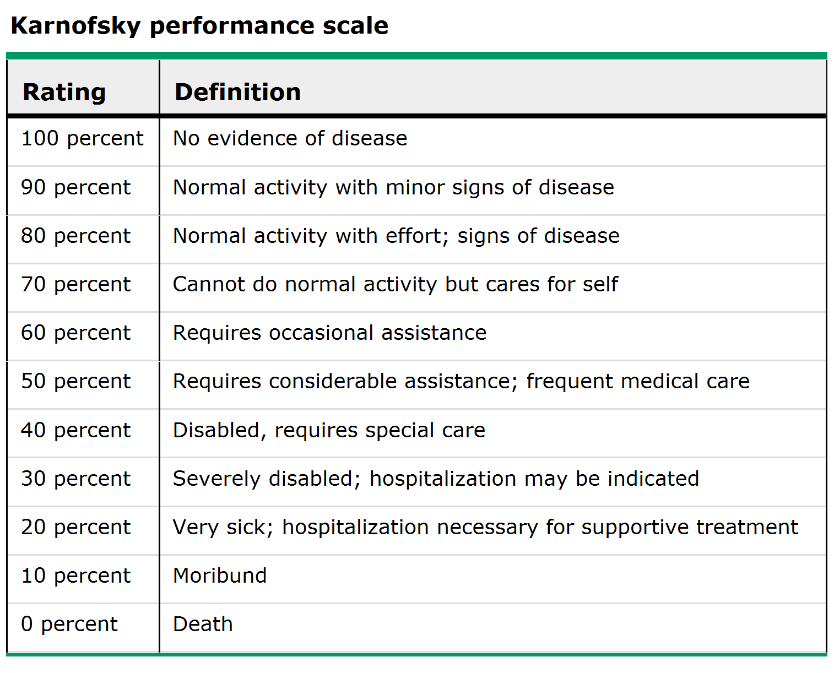

Treatment

- All therapies for Kaposi sarcoma (Kaposi's sarcoma, KS) have been markedly influenced by HAART (highly active antiretroviral therapy), which has decreased the incidence and severity of this disease
- If KS due to immunosuppressant medications, eliminate or reduce medication dosage
- If KS is HIV-related, optimize anti-HIV therapy to reduce HIV viral load

Antiretroviral therapy:

- Optimal control of HIV infection using HAART is an integral part of successful Kaposi sarcoma therapy.
- It should be the first step in therapy.
- Response to such therapy can be anywhere from 20-80% based on stage of disease and the amount of pretreatment
- HAART may be the sole modality used in nonvisceral disease.
- For visceral disease, chemotherapy may be added.
- For locally symptomatic disease, radiation therapy may be introduced

Local therapy:

- Local therapy is best suited for individuals who require palliation of locally advanced symptomatic disease (e.g. radiation) or for individuals who have cosmetically unacceptable lesions.
- This therapy is also well suited for individuals with significant comorbidities and disease refractory to systemic modalities.
- It can provide better cosmesis, control bulky lesions that cause bleeding, pain or, edema, and treat extensive skin disease.
- Local therapy fails to halt the development of new Kaposi sarcoma lesions
- Radiation therapy is the most widely used and effective local therapy
- In patients with widespread skin involvement, extended-field electron beam radiation therapy (EBRT) has been effective in controlling the disease.
- Surgical excision may be of benefit for patients with small superficial lesions.
- The major problem is local recurrence.
- Local lesions can be injected directly with vinblastine, usually repeated in 3-4 weeks; alitretinoin (Panretin) gel is approved for topical use of cutaneous lesions

Systemic therapy (Chemotherapy)

- Palliative systemic therapy is indicated for symptomatic or life-threatening visceral disease, rapidly progressive mucocutaneous disease with pain or ulceration, and symptomatic lymphedema
- The goals of pharmacotherapy for Kaposi sarcoma (Kaposi's sarcoma, KS) are to eradicate the sarcoma, reduce morbidity, and prevent complications
- Systemic chemotherapy, immunotherapy, or antiviral therapy
- Chemotherapy is used with palliative intent.
- Chemotherapy is indicated for symptomatic visceral or rapidly progressive mucocutaneous disease for which a rapid response is desirable.
- It is used in disseminated disease not amenable to local modalities
- Initially, vincristine-, vinblastine-, and bleomycin-containing regimens were used.
- Etoposide and doxorubicin regimens were the second-line standards.
- These agents are capable of achieving rapid tumor regression and palliation of tumor-related symptoms but at a cost of myelosuppression and risk of opportunistic infections
- Combination therapy with regimens such as ABV (actinomycin D, bleomycin, and vincristine) versus single-agent therapy such as doxorubicin cause higher response rates but similar time to progression and overall survival.
- Several single cytotoxic agents are approved by the Food and Drug Administration (FDA) for AIDS-related Kaposi sarcoma and include liposomal doxorubicin (Doxil) for previously treated patients, liposomal daunorubicin (DaunoXome) for first-line use, and paclitaxel (Taxol) for second-line use.

